Subjective Questions

**Question 1:**

What is the optimal value of alpha for ridge and lasso regression? What will be the changes in the model if you choose double the value of alpha for both ridge and lasso? What will be the most important predictor variables after the change is implemented?

**Ans:**

* Optimal value of alpha for Ridge regression is 4 and for and Lasso regression is 0.0001
* Doubling the value of alpha for Ridge and Lasso regression does not have much impact on the overall model, as the value of alpha is relatively small even after doubling. Only few variable coefficients got changed

|  |  |  |
| --- | --- | --- |
|  | Original | Double |
| Scores Ridge |  |  |
| Scores Lasso |  |  |
| Coefficients Ridge |  |  |
| Coefficient Lasso |  |  |

**Question 2:**

You have determined the optimal value of lambda for ridge and lasso regression during the assignment. Now, which one will you choose to apply and why?

**Ans:**

As R2 Score and Mean Square Error for both the Ridge and Lasso is the same, we would choose Lasso as it does feature reduction by making the coefficients as zero. This helps in simplifying the model

**Question 3:**

After building the model, you realised that the five most important predictor variables in the lasso model are not available in the incoming data. You will now have to create another model excluding the five most important predictor variables. Which are the five most important predictor variables now?

**Ans:**

Top 5 predictor in the current Lasso model is

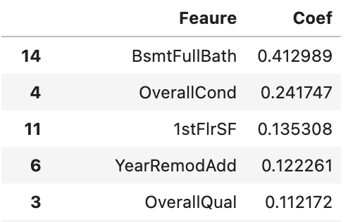

After removing these predictor and rebuilding the Lasso model we get the next top 5 predictors as

With scores as

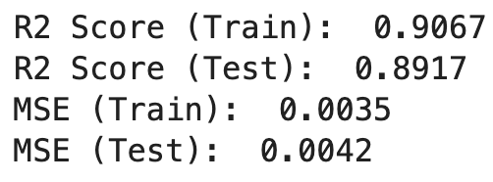

**Question 4:**

How can you make sure that a model is robust and generalisable? What are the implications of the same for the accuracy of the model and why?

**Ans:**